Read Me Report

Introduction

For my web development module, we have been asked to create a resume using a website format. The brief states the resume should include web pages which include an index page, curriculum vitae page, contact page and a bio. Before I even started creating my portfolio I realised I needed to carry out research on other interactive portfolios. The reason for the research was to gain inspiration and identify professionalism. While creating our website, we had to all so ensure that we used good practice. The websites I looked at were:

* <http://kellyedmunds.co.uk/>
* <https://joel.sh/>
* <http://ryanscherf.net/>
* <http://www.rleonardi.com/interactive-resume/>

I found these sources very helpful as they are unique, each website had a different concept which had displayed different formats and layouts. This was beneficial as it inspired me to think of new ideas.

**Editor**

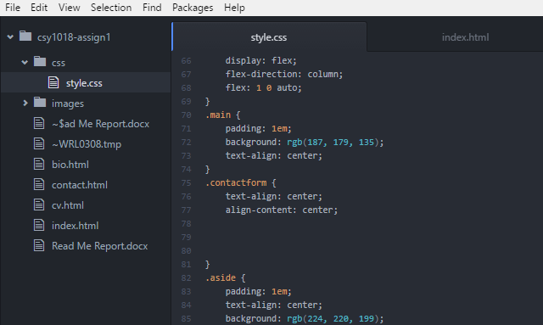

To create my website, I used “Atom” this has allowed me to create and use codes to build my website. It is a very useful editing tool as it allows you to download packages which can help make the process a lot easier. Atom offers packages such as “Smart Autocompletion” which automatically rights codes and commands for you once it knows what you want it to do.

**Wireframes**

Before I started creating my website I created wireframes, so I could have rough plan of what it should look like. This was useful as I could refer to my wireframe plans when I was implementing the designs for the layout of my website.

**Index page (Index.html)**



Thasin Miah’s Resume

**Portrait**

Contact

CV

Bio

Home

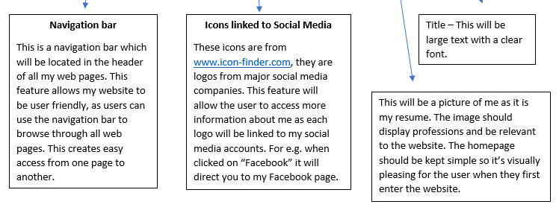

**Bio Page (Bio.html)**

Family Photo

Text

Text

Contact

CV

Bio

Home

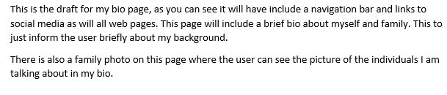

**CV Page (CV.html)**

Text

Text

Contact

CV

Bio

Home

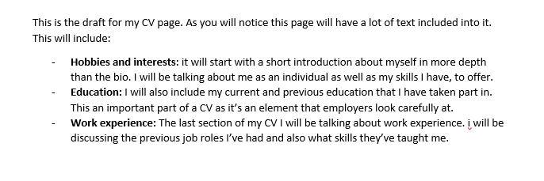

**Contact Page (contact.html)**

Send

First Name

Email

Second Name

Contact

CV

Bio

Home

This is the last page of my website, it is a draft of the contact page. As you will notice it has a consistent look like my other web pages as it includes a navigation bare as well as social media links. This page includes static contact form on the page where users can enter details and comments in case they have any queries.

**Evidence of good practice**

**Styles**

Throughout my project, you will see evidence of good practice, as I have not included any style codes or tags within any HTML page. I have created a separate style sheet which includes all the CSS for my website. This is so that the html page is easier to read as it won’t have style tags everywhere.

**Visuals**

Once I had carried out my research I had realised that I need to make sure that my website is visually pleasing. I knew I needed to ensure that my website held a consistent look throughout. I had noticed that many websites don’t include flashy images and bright colours. I then designed my wireframes so that they were visually pleasing, this was another form of good practice I had used.

**Navigation**

From my web development lectures, I had learnt that navigation is very important and it is also a form of good practice. I have included a navigation bar within my website so users will be able to freely navigate through out my web pages. This is to ensure that the user is having a smooth experience.

**Images**

Another form of good practice I used was making sure that my images were nicely presented. To do this I needed to ensure that my images were good quality and were not stretched out. This is an important factor as it does not look professional if images are not visually pleasing to the eye.

**Icons Linked to social media**

I included links on my website so users could access social media accounts straight from my website as the links are included in the footer of every webpage. This is a feature I added to increase the level of interactivity.

**Bad practice**

**Text**

Most of my webpages have a good amount of text, I have created a balance so that the user doesn’t have to face a lot of text whereas on my CV page there is a lot of text. This is because, to meet all the requirements from the brief I had to include a large amount of text.

**Image relevance**

During the end of building my website I had noticed that I had used some forms of bad practice as my images were not relevant to my theme. I realised that a resume needed to look official so I decided to change the images to something more relevant and professional.

**References of sources that I have used:**

[www.icon-finder.com](http://www.icon-finder.com) – I used this website to find my icons so I could link my social media to my website. I browsed through and picked four icons that I liked, these were Facebook, Instagram, Twitter and the YouTube Icon.

<http://www.w3schools.com> – I used this website when implementing my navigation bar, I browsed through the popular navigation bars used and made a choice on which one to use. I used a horizontal navigation bar.

[www.codeacademy.com](http://www.codeacademy.com) – I used this website as a source to practice my coding, I took part in tasks where I was taught to create codes, I then used some parts in my website.

<http://www.w3schools.com> – I used this website to look for codes which would help me improve my project. At times, I searched specific codes such as:

<img class="portrait" img src="images/Profilepic.jpg" alt="Thasin" />

<http://www.w3schools.com> – I used w3cschools to find a suitable contact form which I could put on my contact page.

<https://fonts.google.com/> - I used google fonts to find a suitable font for the text on my website. I browsed through and picked a font, I then included it into my website.